Chemistry 20

Lesson 7 – Lab safety

Assignment – 10 top rules of conduct
Study each of the safety rules listed below, then give a reason for each rule.

1. Never engage in practical jokes.

2. Loud talking and excessive discussion of matters unrelated to the experiment under way can be dangerous.

3. Dispose of waste chemicals and reagents as indicated by your instructor. This is especially important when you use flammable materials.

4. Never return unused reagents to a stock bottle.

5. Use only the amount of chemicals and reagents called for in the experiment.

6. Always wash your hands thoroughly at the end of a lab experiment.

7. Always leave your lab work area clean and dry.

8. Be sure the gas and water outlets are turned off completely after use.

9. Perform only the experiments that have been approved by your instructor.

**10. When in doubt: ASK FIRST!

Assignment – Bob and Jane
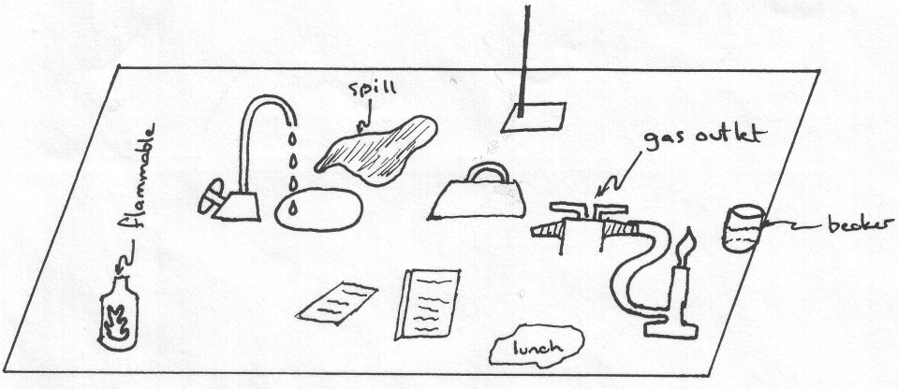
Bob and Jane arrive at class late. Everyone in class has already begun to do the lab. They had been working late the night before and had not had an opportunity to read the lab in advance. They look around to see what everyone else is doing and begin immediately so they can finish on time. Bob needs three beakers with different chemicals in them. He weighs them out but measures out too much of one so he puts it back into the original container. As he measures out another one, some of the chemical spills on the balance. He dusts it off onto the floor. Meanwhile Jane starts the Bunsen burner and then takes a graduated cylinder to get some nitric acid. She pours a little too much into the cylinder. To get the volume to the proper level she dumps the excess into the sink. She gets back to the lab station at the same time as Bob. In Bob's haste, he upsets a beaker containing silver nitrate. He hastily cleans it up and puts everything in the garbage. Bob takes the beaker he thinks chemical A is in and then begins the experiment. The experiment is finished just as the bell goes. They rinse the equipment into the sink. They grab all of the equipment and put it away quickly. They then go to their next class
Description of Bob:
tall, dark, and handsome
has shoulder length hair
uses contacts
blue jeans and shirt
Description of Jane:
long blonde hair
wears five rings at a time
wears long gold necklace
wears a loose silk blouse and open toed shoes

Read the description above including the diagram. On a separate sheet of paper list twenty things that Bob and Jane did wrong and then state what they should have done for each item.

